D-RAC: Understand the Document Once, Stop Rewriting Every Chunk
Yellow.ai separates document understanding from chunk planning, matching aggregate agentic retrieval quality with lower chunking-stage costs
A number in a table is useful only if you know what its row and column mean. People recover that context almost effortlessly from a PDF. A text extractor may not. For retrieval-augmented generation (RAG)—finding source material before a model answers a question—the damage happens before retrieval even starts: the evidence has been broken into text that no longer stands on its own.
Agentic chunking offers a repair: a large language model reads the material and rewrites it into coherent passages. But generating the document again costs output tokens and creates opportunities to change the source. If a knowledge-base team keeps experimenting with chunking policies, why should each experiment require another rewrite?
Document Retrieval-Aware Chunking, or D-RAC, from Yellow.ai separates understanding from grouping. A multimodal model converts page images into structured text once. A later planner returns element identifiers (IDs), and local code assembles the passages. In Figure 1, the important distinction is not simply model versus no model, but what each model call is allowed to produce.
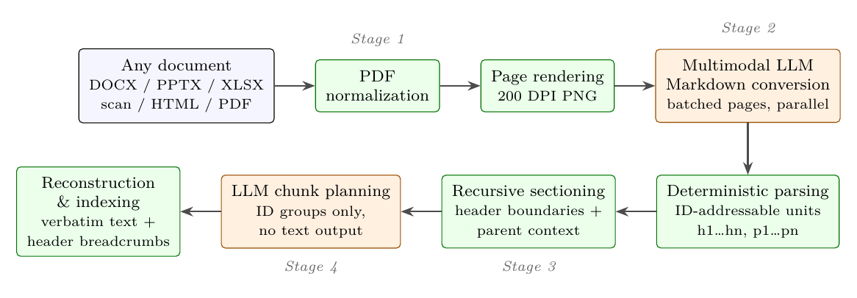
Figure 1. The D-RAC pipeline (paper Figure 1). Orange stages invoke a model; green stages are deterministic. Page conversion recovers text and structure. Chunk planning emits element-ID lists, and the final text is reconstructed from the stored conversion.
Think of it as cataloging a document before rearranging its folders, rather than copying every page each time. The qualification matters: the no-rewriting guarantee begins with the converted text. It does not guarantee that the first reading of the page was correct.
Paper: https://arxiv.org/abs/2609.24220
Evaluation dataset, RAG-Multi-Corpus: https://github.com/udayallu/RAG-Multi-Corpus

Structure is part of the evidence
Fixed-size chunking is cheap and straightforward. What it cannot do is repair structure already lost during extraction: interleaved columns, detached headings, or values stripped of their conditions. An embedding maps text to a numerical representation for similarity search. If that text has lost its context, a better embedding model cannot be assumed to recover the missing relationships.
D-RAC extends W-RAC, an earlier approach for web content, to renderable documents. Conventional tools first convert non-PDF inputs to PDF, then render pages as images for a shared visual pipeline. That is an architectural capability, not a result established across formats here: every input in the main evaluation was already a PDF. Office-file and scanned-document conversion were not tested in that benchmark.

Convert for meaning; plan with identifiers
A multimodal model—one that processes images as well as text—first produces Markdown, a plain-text format with simple markers for structures such as headings. The main experiments use Gemma-3 27B. Conversion instructions preserve prose and heading levels, but deliberately turn each table row into a self-contained statement carrying its column context.
That table rule is more than a formatting choice. Different products or policies can occupy separate rows. Collapse them into a sentence joined by “or,” and a retrieved passage may imply that conditions can be mixed freely. Figure 2 shows the alternative: keep each row distinct and carry its column context into the sentence. The objective is an independently understandable fact, not a visual replica of the table.
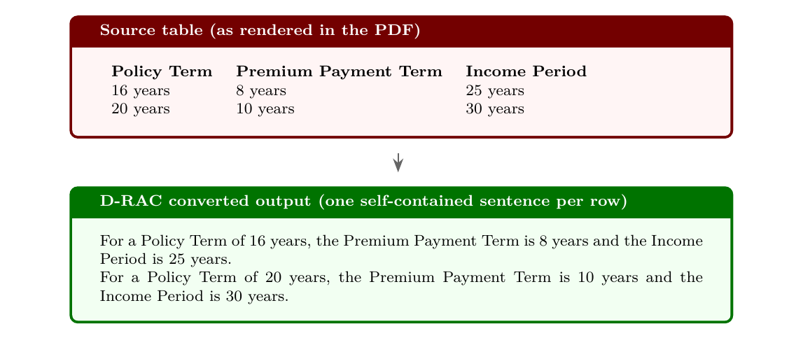
Figure 2. Retrieval-aware table normalization (paper Figure 2). Each row becomes an independently embeddable statement with its full column context. Distinct rows are not merged into disjunctive sentences, preserving the association between conditions and values.
Not all visual information survives this conversion. Logos, charts, and decorative graphics are omitted rather than described. That avoids unreliable generated image descriptions, but it can also exclude evidence available only in a chart. Converting tables into prose and dropping charts are separate decisions with different consequences.
A deterministic parser then assigns IDs to headings and content blocks. Large documents are recursively divided at heading boundaries, using a budget of 60 elements per planning call and retaining ancestor headings. The planner receives IDs, truncated text previews, and hierarchy metadata. It groups 3–8 content blocks around a topic and returns an ordered ID list—not newly generated prose.
Local code resolves those IDs back to the converted text, restores the full ancestor-heading chain, and checks content coverage. Missing content IDs are collected into a fallback chunk. This removes prose regeneration as a source of changes during planning. It does not prevent a poor grouping decision or repair a mistake already introduced by conversion.

Retrieval: aggregate parity, not a universal win
The main evaluation uses the PDF subset of RAG-Multi-Corpus: 236 documents and 795 pages spanning fictional organizations in automotive, academia, cloud services, enterprise technology, and banking. Retrieval is evaluated on 762 queries with supporting-fact annotations from four organizations. The cloud-services organization has no annotated queries in the reference set.
All systems use Titan Text Embeddings V2 and the same cosine-similarity retrieval protocol. The fixed-size baseline splits rule-extracted text into 1,000-character chunks with 200-character overlap. The agentic baseline uses reference chunks supplied with the benchmark, which the paper says were produced from clean structured sources. D-RAC starts from rendered PDF pages. This is therefore a comparison of ingestion pipelines, not an experiment changing only the chunking algorithm.
Recall@6 measures the share of supporting facts covered by the first 6 retrieved results. Precision@6 measures the fraction of those results judged relevant, while mean reciprocal rank (MRR) rewards placing the first relevant result early. A chunk is relevant when it contains at least 60% of a supporting fact’s content words. These are word-overlap-based retrieval measurements, not tests of final answer accuracy.
Table 1. Selected aggregate retrieval results (paper Table 6; 762 queries; higher is better)
Method | Recall@6 | Precision@6 | MRR
Fixed-size | 0.717 | 0.203 | 0.602
Agentic | 0.795 | 0.197 | 0.682
D-RAC | 0.798 | 0.199 | 0.690
Embedding and retrieval protocols are shared; upstream document representations differ. This selection does not imply that D-RAC beats fixed-size chunking on every metric.
D-RAC reaches 0.798 Recall@6 versus 0.795 for agentic chunking—a difference of just 0.003. It matches or exceeds the agentic reference on all seven reported aggregate metrics. Against fixed-size chunking, the relative gains are 11.3% in Recall@6 and 14.6% in MRR. Yet the fixed-size baseline has higher Precision@6. “Better on every metric” would be the wrong summary.
Query categories also complicate the average. For boolean queries—factual yes-or-no questions—the agentic baseline achieves 0.86 Recall@6, compared with D-RAC’s 0.82. The defensible takeaway is comparable aggregate retrieval quality in this evaluation, not superiority for every task.

The savings belong to the chunking stage
Avoiding regenerated prose changes the output budget dramatically. The paper reports a drop from 270,454 to 11,714 chunking-stage output tokens, a reduction of 95.7%. Tokens are the units used to measure model text processing and generation. Here, however, the accounting converts characters at 4 characters per token; the reported totals should be understood as character-based accounting, not exact provider billing counts.
Applying the paper’s pricing scenarios to the 236-document corpus brings chunking cost from $2.815 to $0.624 under GPT-4.1 rates, a 77.8% reduction. Under Gemini 2.5 Pro rates, it falls from $3.112 to $0.448, or 85.6%. These are rate-based comparisons using the token accounting, not evidence that both models independently underwent the full quality evaluation. They are not current API price quotes either.
For time, the paper compares D-RAC’s 541.8 seconds of planning with 2,167.5 seconds of agentic chunking measured in the earlier W-RAC experiments on the same corpus, reporting a 75.0% reduction. These cost and time savings exclude the first multimodal conversion. Conversion plus planning took 71.7 minutes in the reported run. Cheaper chunking is not the same as an equally large reduction in end-to-end ingestion cost.
The pipeline produced 1,748 chunks with no reported conversion or chunking errors. Successful execution and coverage checks are not a fact-by-fact audit of the source pages. A separate 503-page prospectus took 21.6 minutes to convert with Gemma-3 27B and 13.4 minutes with 12B; its 5,060 elements were planned in 68.7 seconds across 95 section calls. That supports long-document feasibility, not equivalent retrieval quality between the two conversion models.

Cache the understanding, keep the caveats
For teams repeatedly tuning a knowledge base, D-RAC offers a design worth testing: persist the expensive document-understanding output, then experiment with grouping over IDs. When the conversion remains reusable, a new chunking policy does not require generating the whole document again. Changes to source content or conversion policy may still require another conversion pass.
The evidence has clear boundaries. The main benchmark does not establish cross-format conversion quality; charts are discarded; and word-overlap retrieval metrics do not replace end-to-end question-answering tests. The paper also reports no component-isolation ablation—removing table normalization, heading hierarchy, or the no-merge rule individually to measure their effects. The overall gains cannot be assigned quantitatively to any one of those choices.
The useful lesson is not simply to use models less. It is to make each generation necessary: recover structure when reading pages, express grouping decisions when planning chunks, and let code reconstruct the stored text. D-RAC demonstrates a cheaper planning path while leaving the remaining verification work visible.

